CC 207B Unit 7 Exercise
Name:Joseph Angelo O. Japitana Date: 11/6/2026
Year and Section: BSIT 3-B
Note: Upload your Flutter project to your assigned folder here -> https://github.com/WVSU-BSIT-Batch-2028/CC-207B_26-27_Activities. Read the instructions on submitting, including the file name/folder conventions in the GitHub repository.

I. My Profile App part 3. Your profile app gets a fourth tab, My Shelf, with three tabs of its own. Books searches Open Library, a free public API. Movies searches OMDb, a public API that needs a free key. My Picks shows the books and movies you recommend, which you write in the same CMS you chose for the Unit 7 assignment. A pick only stores the book's or movie's ID and your note; when someone opens it, the app gets the cover, the year and the summary from the API. That is how real apps combine a CMS (your own words) with APIs (data someone else keeps up to date).

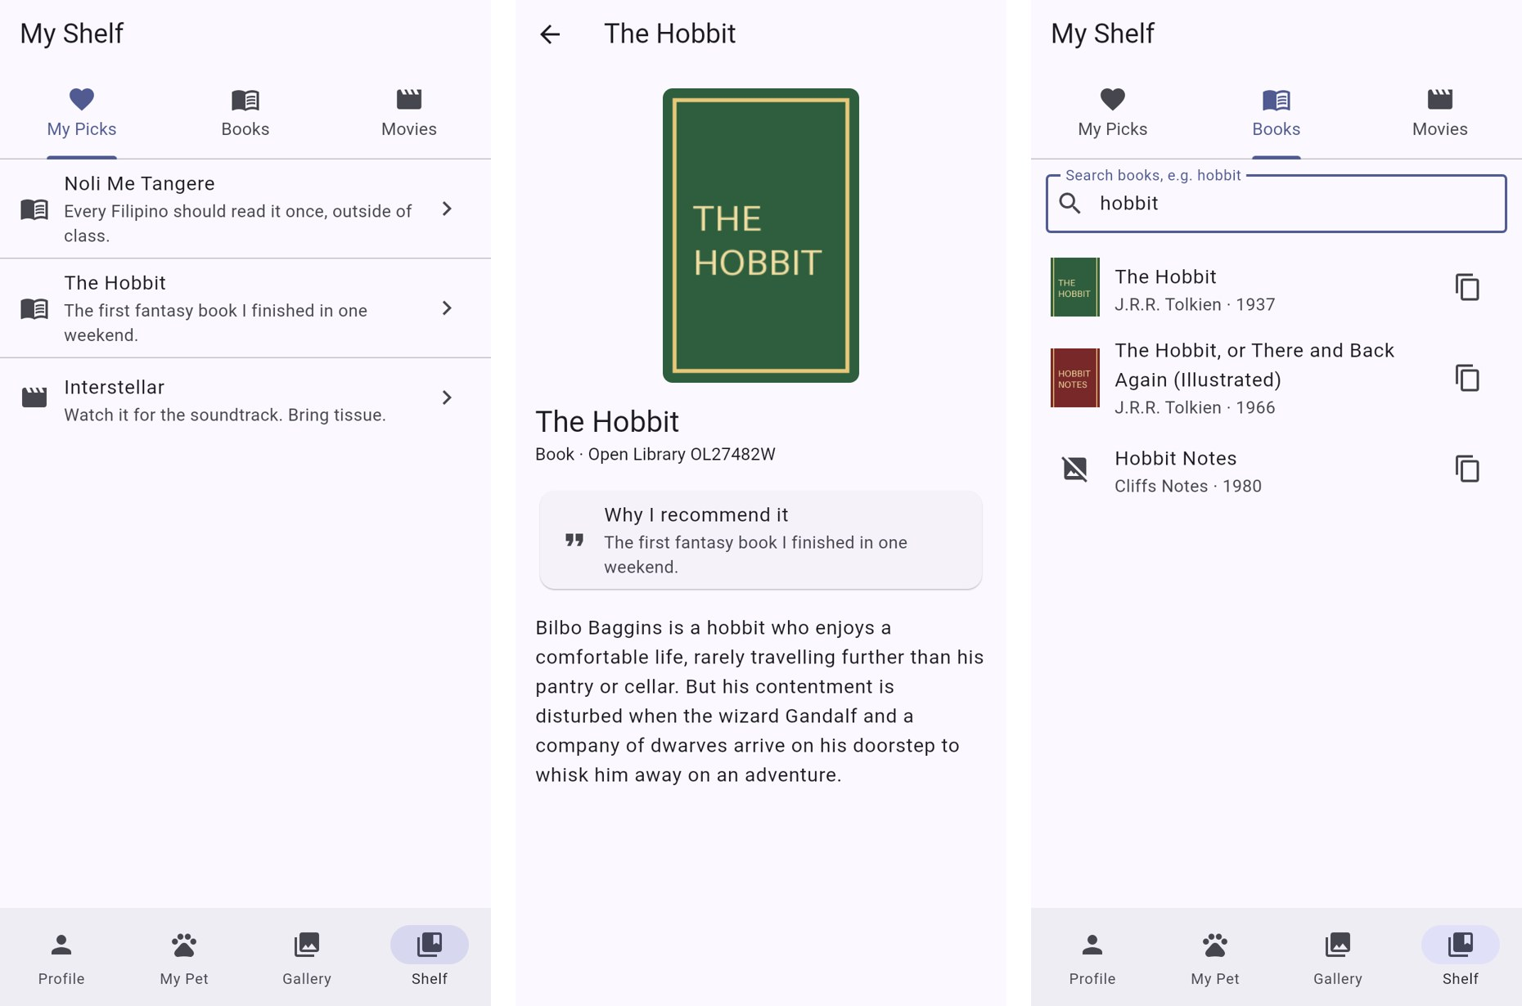
A sample solution: picks from the CMS, a pick's details from Open Library, and book search. (The covers here are placeholders.)

Before you start
- Copy your Unit 6 exercise project and rename the copy <lastname>_unit7_exercise.
- Run flutter pub add http.
- Get a free OMDb API key at omdbapi.com/apikey.aspx (it is emailed to you; the free key allows 1,000 requests a day).
- In your CMS, create a content type Pick with the fields title (short text), kind (Strapi: Enumeration with the values book and movie; Contentful and Sanity: short text / string), externalId (short text) and note (long text). Allow read access the same way as in the assignment.
- Run the app with your values, for example (a .json file with --dart-define-from-file works too):
flutter run --dart-define=OMDB_KEY=your-key --dart-define=CMS_URL=http://localhost:1337

The two APIs:
 | Open Library (books) | OMDb (movies)
Key | None | apikey=your-key in the query
Search | https://openlibrary.org/search.json?q=hobbit&fields=key,title,author_name,first_publish_year,cover_i&limit=20 | https://www.omdbapi.com/?apikey=KEY&s=interstellar&type=movie
Search answer | {"docs": [{"key": "/works/OL27482W", "title": "The Hobbit", "author_name": ["J.R.R. Tolkien"], "first_publish_year": 1937, "cover_i": 14627509}]} | {"Search": [{"Title": "Interstellar", "Year": "2014", "imdbID": "tt0816692", "Poster": "https://..."}], "Response": "True"}
Details by ID | https://openlibrary.org/works/OL27482W.json | https://www.omdbapi.com/?apikey=KEY&i=tt0816692&plot=short
Image | https://covers.openlibrary.org/b/id/14627509-M.jpg | The Poster field ("N/A" when there is none)
Surprises | author_name and cover_i can be missing; description is a String or {"value": "..."} | Not found is status 200 with {"Response": "False", "Error": "Movie not found!"}

Part A. The Shelf tab
a. Add a fourth NavigationDestination, Shelf, and a fourth page in your IndexedStack.
b. ShelfScreen is a DefaultTabController with three tabs: My Picks, Books and Movies (Unit 6).

Part B. Book search with Open Library
a. A Book class with Book.fromJson. Keep only the ID part of the key ("OL27482W"):
factory Book.fromJson(Map<String, dynamic> json) => Book(
workId: (json['key'] as String).split('/').last,
title: json['title'] as String,
// author_name is missing for some books, and it is a list.
authors: [...?(json['author_name'] as List<dynamic>?)?.cast<String>()],
year: json['first_publish_year'] as int?,
coverId: json['cover_i'] as int?,
);

b. An OpenLibraryApi class with Future<List<Book>> search(String query). Build the URL with Uri.https (it encodes spaces for you), check the status code, and decode the JSON.
c. A search box that waits until the user stops typing for 500 ms before it sends one request (debounce, slide 51), and only for 3 letters or more:
Timer? _debounce; // import 'dart:async';

void _onChanged(String text) {
_debounce?.cancel(); // the user typed again: forget the old timer
_debounce = Timer(const Duration(milliseconds: 500), () {
final query = text.trim();
if (query.length < 3) return;
setState(() => _results = api.search(query)); // a new Future for the FutureBuilder
});
}
// and in dispose(): _debounce?.cancel();

d. Show the results with a FutureBuilder: loading, error, "Nothing found", and the list. Each result shows the cover (or an icon when there is no cover_i), the title, the first author and the year.
e. Each result has a copy button that copies its ID with Clipboard.setData and shows a SnackBar. You will paste these IDs into your CMS in Part D.
Part C. Movie search with OMDb
a. Read the key with const omdbKey = String.fromEnvironment('OMDB_KEY');. When it is empty, the Movies tab shows how to pass it instead of searching.
b. An OmdbApi class with search(query). OMDb says "not found" with status 200, so check the body too:
final json = jsonDecode(response.body) as Map<String, dynamic>;
if (json['Response'] == 'False') {
final error = json['Error'] as String? ?? 'OMDb error';
if (error == 'Movie not found!') return const []; // empty, not an error
throw ApiException(error); // e.g. "Invalid API key!"
}

c. Show the results like the books (poster or icon, title, year, copy button). Treat a Poster of "N/A" as no poster.
Part D. My Picks from your CMS
a. In your CMS, publish at least 4 picks (2 books and 2 movies) with the IDs you copied in Parts B and C and a short note on why you recommend each one.
b. A Pick class and a PickSource interface with Future<List<Pick>> fetchPicks(), and a class for your CMS that implements it. Reuse what you learned in the assignment: the same URL style, header and JSON shape, with picks instead of fair-events (Strapi) or pick instead of fairEvent (Contentful, Sanity).
c. The My Picks tab lists the picks (a book or movie icon, the title, the note) with all four states and pull to refresh. The request starts in initState, not in build().
d. Tapping a pick opens a PickDetailScreen that loads the details from the right API with the pick's externalId: Open Library works/<id>.json for a book, OMDb ?i=<id>&plot=short for a movie. Show the image, the title, your note and the summary. Open Library's description comes in two shapes; a switch handles both:
final description = switch (json['description']) {
final String text => text, // "description": "..."
{'value': final String text} => text, // "description": {"type": ..., "value": "..."}
_ => 'No description yet.',
};

e. Change a note in the CMS and pull to refresh. The new note appears without a rebuild.

Evidences (Screenshot that the application is working):


